Neural Network-Based Personalized FPS Setting Optimization Using Controller Telemetry and Hand-Motion Tracking

by

Sense2Aim
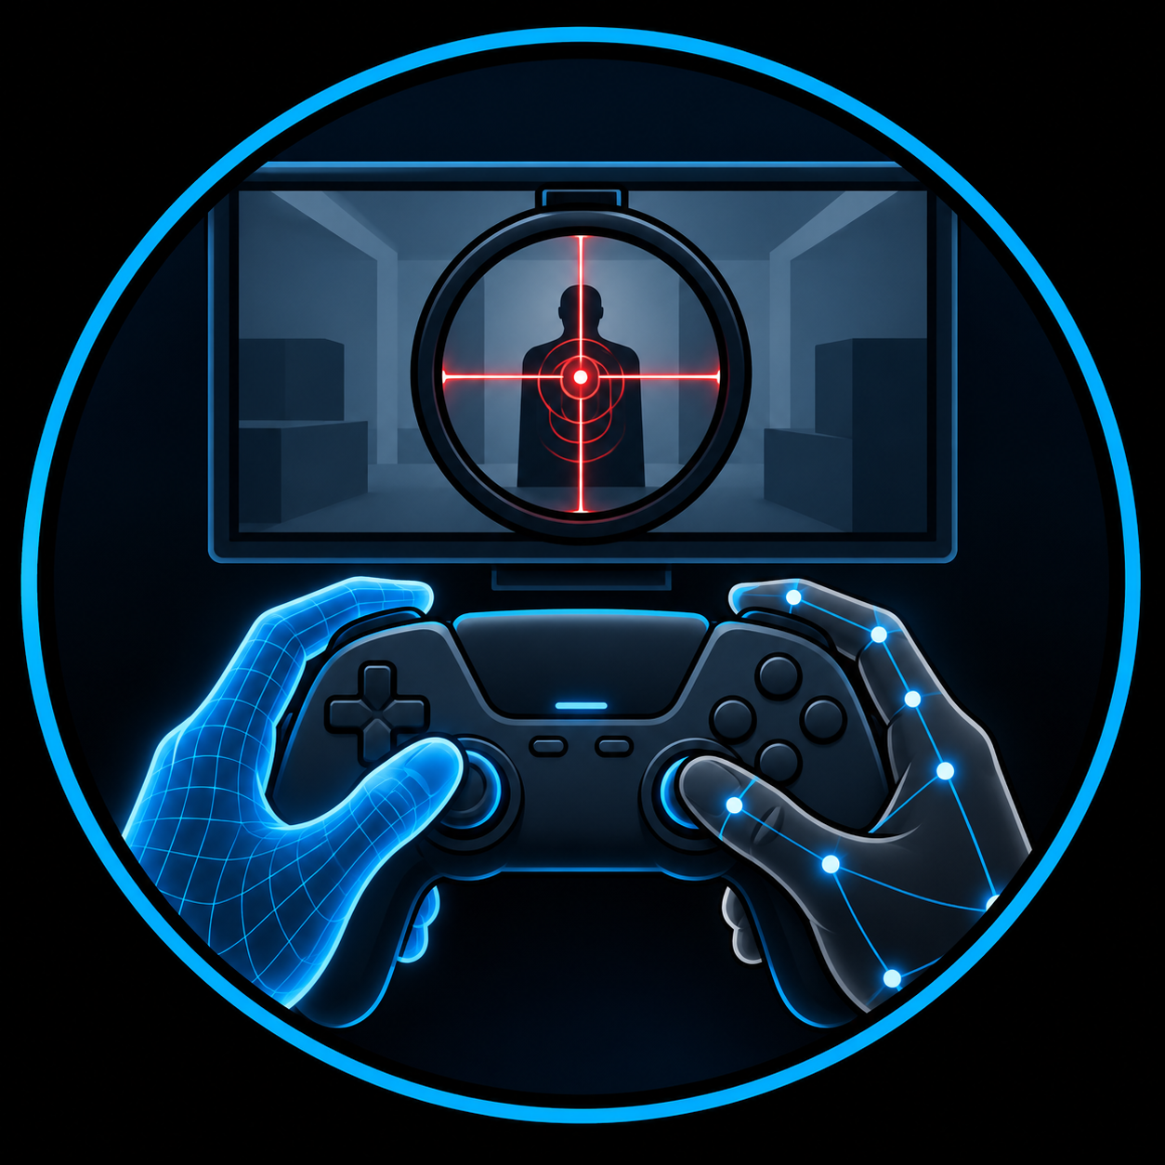

Maira Penayo Nunez - Electrical & Computer Engineering
Noah Maniace - Electrical & Computer Engineering
Sofia Filgueira Fernandez - Computer Science & Mathematics
Mallie Lawson - Computer Science
Kobe Thurmond - Computer Science

for

CS 480: Capstone Project Designs
Under Supervision of Dr. Zahmeeth Sakkaff & Dr. Mingyu Lu

September 8th, 2026

https://github.com/sf00053/Sense2Aim.git

- Abstract
First-person shooter (FPS) games provide players with adjustable controller settings, such as aiming sensitivity, dead zones, and response curves, that determine how analog-stick inputs are translated into in-game aiming movement. Players commonly select these settings through trial and error, personal preference, or generalized recommendations, despite individual differences in hand movement, controller use, and aiming behavior.

This project proposes a machine-learning-based system for investigating personalized FPS controller-setting optimization. Participants will complete controlled target-acquisition and tracking tasks under different controller configurations while the system records physical hand and controller motion, controller telemetry, and gameplay performance. Millimeter-wave (mmWave) radar will serve as the primary motion-sensing technology, while computer vision will provide a complementary reference for hand and controller movement. Performance will be evaluated using measures such as accuracy, target-acquisition time, aim error, overshoot, and corrective movements.

Neural-network approaches will be developed and evaluated to determine whether the collected data can identify player-specific relationships between controller configuration and aiming performance, including whether physical-motion measurements provide useful predictive information beyond controller telemetry and gameplay data alone. The expected outcome is a working prototype that evaluates the feasibility of using objective behavioral and performance data to recommend individualized FPS controller settings.

- Problem Description/Statement
  - Real-World Problem
FPS controller configuration presents a speed-precision trade-off: settings that allow rapid movement toward a target must also provide sufficient control for precise positioning and correction. Research on FPS aiming has shown that successful aiming consists of multiple measurable phases, including an initial response, primary movement, corrective movement, and final stabilization, and that these movement characteristics vary with player performance and skill (Warburton et al. 2023). Studies of analog-thumbstick target acquisition similarly demonstrate measurable differences in movement time, error, and performance associated with controller-based aiming tasks (Claypool 2018; Natapov, Castellucci, and MacKenzie 2009).

However, the physical interaction between the player and controller is not fully represented by conventional input telemetry or final gameplay outcomes. An analog-stick value indicates the input registered by the controller, but it does not completely describe the physical behavior that produced it. Additional characteristics such as movement timing, stability, consistency, and corrective behavior may distinguish how different players produce similar inputs or how the same player responds to different controller configurations.

The central engineering problem is therefore determining whether measurable characteristics of a player's physical interaction with a controller provide useful information beyond conventional controller and gameplay data for evaluating individualized controller configurations. Before personalized recommendations can be made, these characteristics must be captured reliably, distinguished from normal trial-to-trial variation, and related to measurable changes in aiming behavior and performance. Their contribution must also be compared against models using controller telemetry and gameplay data alone to determine whether physical-motion sensing provides meaningful additional information behavior and performance.

  - Relevance & Significance of Engineering Problem
This problem involves a human-machine interaction spanning physical human motion, an electronic input device, and virtual system response. These stages occur as part of the same aiming action but produce fundamentally different forms of information. Establishing relationships among them requires accurate sensing, synchronized data acquisition, signal processing, and quantitative analysis.

Capturing the physical component is itself an engineering challenge. Controller-related hand movements may be small, rapid, closely spaced, and partially obscured by the controller, which can limit purely visual observation. Previous work has demonstrated that mmWave radar can capture fine hand and finger motion and operate when motion is optically obscured, supporting its investigation alongside computer vision in this project (Lien et al. 2016; Wei et al. 2022; Amihood and Poupyrev 2021).

Addressing these challenges requires knowledge from several engineering and computational disciplines. The electrical engineering aspects of the project include radar sensing, signal acquisition, and signal processing. Meanwhile, computer engineering contributes to sensor integration, controller interfacing, synchronization, and the connection between hardware and software components. Computer science is central to processing the collected data, developing the software pipeline, and designing and evaluating the machine-learning models used to identify patterns across player behavior and controller configurations. Mathematical and statistical methods are also necessary for analyzing experimental data, evaluating model performance, and determining whether observed relationships are meaningful and consistent.

The significance of this problem extends beyond FPS controller configuration. At a broader level, it examines whether measurable characteristics of an individual’s physical interaction with a control device can provide useful information for adapting a human-machine interface to that user. FPS aiming provides a practical environment in which this question can be investigated through repeatable tasks and quantitatively measured outcomes.

- Background & Literature Review
Warburton et al. (2023) identified measurable kinematic characteristics associated with FPS aiming performance and skill, while Rogers et al. (2024) demonstrated the use of controlled flicking and tracking tasks for evaluating shooting proficiency. Controller-focused studies have similarly examined analog-thumbstick target acquisition and the relationship between physical input and virtual response (Natapov, Castellucci, and MacKenzie 2009; Claypool 2018). Ivkovic et al. (2015) investigated how latency and control-display gain affect aiming, while Shim et al. (2023) demonstrated with ExpanStick that physical measurements beyond conventional two-dimensional thumbstick position can be incorporated into FPS control mappings. Together, these studies establish quantitative methods for evaluating aiming and controller interaction, but they do not address individualized controller-setting recommendations.

Studies have also demonstrated that player behavior can support personalization. Lange et al. (2022) identified player- and skill-related patterns in low-level FPS input sequences, indicating that temporal input behavior can contain information characteristic of individual users. More directly, Krishna (2025) integrated machine learning with an FPS aim trainer to determine sensitivity settings from measured player performance. This provides an important precedent for data-driven sensitivity optimization. Still, the approach relies primarily on performance within the aim-training environment rather than independently measuring the physical behavior used to generate controller inputs. The proposed project therefore does not claim machine-learning-based sensitivity optimization itself as its primary contribution.

MmWave radar provides a potential means of capturing this additional physical information. Soli demonstrated that mmWave measurements can characterize fine hand and finger gestures (Lien et al. 2016), while IndexPen extended radar-based interaction to small two-finger movements (Wei et al. 2022). Lin et al. (2025) further demonstrated radar-based handwriting recognition with fingertip tracking. Radar has also been investigated in gaming-related environments: Ding et al. (2026) demonstrated device-free gaming using mmWave sensing, and Mei et al. (2024) showed that mmWave measurements can reveal physical motion associated with virtual-reality controller use. Although these studies establish the feasibility of radar for fine motion and gaming interaction, they primarily use motion for recognition, tracking, or direct interaction rather than examining how a player operates a conventional controller under different settings.

Radar measurements can be processed into several representations of motion, including range, radial velocity, angle, Range-Doppler information, micro-Doppler signatures, and point-cloud sequences. Wang et al. (2025) reviewed the complementary characteristics of mmWave radar and other sensing modalities, including vision, as well as the limitations of individual sensors. This supports investigating radar alongside computer vision rather than assuming that either modality alone is sufficient. Because the usefulness of particular radar representations and neural-network architectures will depend on the motion observed during controller use, candidate representations and models will be evaluated experimentally rather than fixed in advance.

Overall, prior work has separately established methods for measuring FPS aiming, characterizing controller interaction, identifying player-specific behavioral patterns, optimizing sensitivity from performance, and sensing fine physical motion. Nevertheless, the literature reviewed for this proposal did not identify a system combining synchronized physical hand and controller motion, controller telemetry, tested controller configurations, and objective FPS aiming performance for player-specific controller-setting optimization. The proposed system will therefore compare models using controller and gameplay data alone with models incorporating radar- and vision-derived motion information to determine whether physical sensing provides useful additional information for individualized controller recommendations.

- Proposed System Features
  - Experimental Platform and Data Acquisition
Our study will initially target approximately 10–20 participants with varying levels of FPS and controller experience. Participants will complete repeated target-acquisition and tracking trials under various controller configurations, allowing both within-player differences across settings and differences among players to be examined. Information about participants’ prior FPS and controller experience may be recorded to provide context for the experimental results.

Controller configurations will vary selected parameters such as horizontal and vertical aiming sensitivity, thumbstick dead zones, and response-curve behavior. A defined subset of configurations will be evaluated rather than every possible combination. Configuration order will be randomized or counterbalanced where practical, and participants will receive a familiarization period before recorded trials to reduce the effects of learning, adaptation, and fatigue.

Target-acquisition trials will measure the sequence from target presentation through the initial aiming response, primary movement, corrective movements, stabilization, and final selection or firing action. Tracking trials will evaluate the participant’s ability to maintain aim on a moving target over a defined interval. These controlled aiming tasks and movement characteristics are informed by previous research examining FPS aiming performance and skill (Warburton et al. 2023; Rogers et al. 2024).

During these trials, the system will collect controller telemetry and available IMU data together with gameplay-performance measurements. Computer vision will provide a complementary reference for hand and controller movement, while mmWave radar will be evaluated as an additional sensing modality for capturing physical-motion characteristics that may not be represented by controller telemetry alone. Previous research demonstrating mmWave sensing of fine hand and finger movements supports its investigation for this purpose (Lien et al. 2016; Wei et al. 2022).

  - Synchronization
Data streams will be collected and timestamped through a Python-based acquisition system and temporally aligned so that physical hand and controller movements can be associated with the corresponding controller inputs and gameplay events. During initial testing, timing offsets and jitter between the different data streams will be characterized to determine whether the synchronization is sufficiently accurate for the proposed analysis.

For mmWave sensing, the initial implementation will use processed or intermediate radar measurements available from the Texas Instruments IWR6843AOPEVM 60-GHz mmWave radar sensor, which may include range, velocity, angle, Range-Doppler, or point-cloud information. These measurements are consistent with established FMCW mmWave radar processing methods (Li et al. 2021). More complex radar acquisition and processing methods may be explored in future expansions if the available measurements are insufficient for characterizing controller-related motion.

  - Data Processing and Neural-Network Modeling
Collected measurements will be organized by participant, trial, and controller configuration. Preprocessing will prepare the data for model development through procedures such as normalization, removal of incomplete trials, and extraction of relevant features from the controller, gameplay, radar, and computer-vision measurements. Temporal characteristics of the aiming motion will be retained where useful so that the models can examine how player behavior develops throughout a trial rather than relying solely on summary measurements.

The neural-network models will be developed to estimate a player's aiming performance under a given controller configuration. Model inputs will include the tested controller settings together with measurements of player behavior, such as controller telemetry, IMU data, and features derived from physical-motion sensing. Outputs will represent measurable aspects of aiming performance, including aiming error, target-acquisition time, overshoot, corrective behavior, and tracking performance. Predicted performance across candidate configurations can then be compared to identify settings associated with stronger performance for an individual player.

The specific neural-network architecture will be selected based on the characteristics of the collected data. Because controller and motion measurements vary over time, models capable of learning temporal relationships may be evaluated. Radar representations containing spatial or time-frequency information may also support convolutional processing. Previous mmWave research has demonstrated neural-network approaches that combine spatial and temporal information from consecutive radar measurements, supporting their consideration for this project (Bai et al. 2025 ). The final architecture will be selected experimentally rather than committing the project to a particular model before the collected data have been evaluated.

To determine whether the additional sensing modalities contribute useful information, models using different combinations of the available measurements will be compared. A baseline model using controller and gameplay data will first establish performance without external physical-motion sensing. Additional models will incorporate computer-vision-derived measurements, radar-derived measurements, and, where appropriate, a combination of both. Comparing these models will help determine whether either sensing modality provides measurable predictive information beyond controller and gameplay data alone and whether combining the sensing modalities provides additional benefit.

Models will be evaluated using held-out data, with measurements from the same trial kept together during data partitioning to reduce data leakage. Rather than defining a universally optimal controller setting, the system will recommend the candidate configuration predicted to provide the strongest performance for that player according to the performance measures evaluated.

- Project Timelines & Resource Allocation

Period | Design Phase | Planned activities
Sept. 2026 | Requirements & Research | Define scope, requirements, variables, metrics, and system components; literature review; draft SRS.
Oct. 2026 | System Design | Develop HLD; define subsystems, data flow, synchronization, and experimental methodology.
Nov. 2026 | Detailed Design | Refine interfaces, data processing, model design, experimental procedures, evaluation methods, and risks; revise SRS/HLD.
Dec.2026 | Final Design Review | Finalize SRS/HLD and system design; complete report/presentation and Spring implementation plan.
Spring 2027 | Implementation & Validation | Integrate system; conduct experiments; process data; develop/evaluate models; validate final system.

Risk | Potential Impact | Mitigation Strategy
Project Scope | Multimodal sensing and ML may exceed available capstone time. | Prioritize core objectives and modular development; defer optional features or model complexity if necessary.
Sensor and Interface Compatibility | Interface, sampling-rate, or timing differences may complicate multimodal data collection. | Define interfaces and synchronization requirements during design; characterize timing during implementation.
Data Synchronization | Timing differences among controller, gameplay, radar, IMU, and computer-vision measurements could reduce the accuracy of multimodal analysis. | Define timestamping and synchronization requirements in the system design and characterize timing offsets and jitter during Spring implementation.
Participant and Data Availability | Limited participants or unusable trials may reduce training/evaluation data. | Use repeated controlled trials and a manageable subset of controller configurations.
Model and Sensor Effectiveness | Radar or vision data may not improve predictions beyond controller/gameplay data. | Compare each modality against a controller/gameplay baseline; treat limited improvement as an experimental result.

- Budget & Resources

Item | Purpose | Cost
TI IWR6843AOPEVM 60-GHz mmWave Sensor | Primary mmWave radar for measuring hand and controller motion. Provides processed radar measurements suitable for the initial capstone implementation while supporting future expansion of the sensing platform. | $156.45
TI MMWAVEICBOOST Carrier Board | Provides the development, configuration, and debugging interface for the radar sensor and supports expansion to additional radar-development capabilities if required in future work. | $261.45
5-V DC Power Supply/Adapters | Provides the external power required by the radar development hardware. | $20
OBSBOT Meet SE Full-HD Webcam | Records hand and controller motion for computer-vision measurements and comparison with radar-derived motion characteristics | $69
AVerMedia StreamLine MINI+ GC311G2 Capture Card | Captures gameplay output for synchronization of gameplay events and performance measurements with controller and physical-motion data. | $80
Sabrent 7-Port USB 3.0 Hub | Provides sufficient USB connectivity for the camera, controller, radar interface, and other acquisition devices | $45
TARION 11-inch Magic Arm | Provides adjustable and repeatable positioning of the radar or other sensing equipment during experiments. | $22
EEEkit 22-inch Webcam Stand | Maintains a consistent camera position and view of the participant's hands and controller. | $13
External SSD — capacity TBD | Stores synchronized radar, gameplay, video, controller, and processed experimental data. Capacity will be determined from expected data volume before purchase. | TBD

The proposed budget represents the resources required for the initial capstone implementation while allowing the system to be expanded if the initial results justify additional capabilities. The radar subsystem will initially use processed or intermediate measurements available through the TI platform rather than requiring raw ADC acquisition. If these measurements are insufficient for characterizing controller-related motion, a TI DCA1000EVM could be incorporated to capture raw radar data and permit custom signal-processing and feature-extraction methods. The experimental design could also be expanded to include additional controller parameters, aiming tasks, participants, and player characteristics, while the modeling stage could evaluate more advanced temporal or multimodal neural-network architectures as the quantity and quality of collected data permit

- References
Amihood, Patrick M., and Ivan Poupyrev. 2021. “Advanced Gaming and Virtual Reality Control Using Radar.” U.S. Patent No. 10,908,696, issued February 2, 2021.
Bai, Weiqing, Siyu Chen, Jialiang Ma, Ying Wang, and Chong Han. 2025. “Gesture Recognition with Residual LSTM Attention Using Millimeter-Wave Radar.” Sensors 25 (2): 469. https://doi.org/10.3390/s25020469.
Claypool, Mark. 2018. “Game Input with Delay—Moving Target Selection with a Game Controller Thumbstick.” ACM Transactions on Multimedia Computing, Communications, and Applications 14 (3): Article 57. https://doi.org/10.1145/3187288.
Ding, Yukuan, Harvy Martinez, Girish Vaidya, Koen Langendoen, and Marco Antonio Zúñiga Zamalloa. 2026. “Towards Device-Free Gaming with mmWave Radar.” In 2026 IEEE International Conference on Pervasive Computing and Communications (PerCom), 1–11. IEEE. https://doi.org/10.1109/PerCom67906.2026.11524493.
Ivkovic, Zenja, Ian Stavness, Carl Gutwin, and Steven W. T. Sutcliffe. 2015. “Quantifying and Mitigating the Negative Effects of Local Latencies on Aiming in 3D Shooter Games.” In Proceedings of the 33rd Annual ACM Conference on Human Factors in Computing Systems, 135–44. https://doi.org/10.1145/2702123.2702432.
Krishna, Sharan. 2025. “Integrating Machine Learning with an FPS Aim Trainer for Optimal Sensitivity Finding.” Senior project, California Polytechnic State University, San Luis Obispo.
Lange, Andrey, Andrey Somov, Anton Stepanov, and Evgeny Burnaev. 2022. “Building a Behavioral Profile and Assessing the Skill of Video Game Players.” IEEE Sensors Journal 22 (1): 481–88. https://doi.org/10.1109/JSEN.2021.3127083.
Li, Xinrong, Xiaodong Wang, Qing Yang, and Song Fu. 2021. “Signal Processing for TDM MIMO FMCW Millimeter-Wave Radar Sensors.” IEEE Access 9: 167959–71. https://doi.org/10.1109/ACCESS.2021.3137387.
Lien, Jaime, Nicholas Gillian, M. Emre Karagozler, Patrick Amihood, Carsten Schwesig, Erik Olson, Hakim Raja, and Ivan Poupyrev. 2016. “Soli: Ubiquitous Gesture Sensing with Millimeter Wave Radar.” ACM Transactions on Graphics 35 (4): Article 142, 1–19. https://doi.org/10.1145/2897824.2925953.
Lin, Jyun Jhih, Yen Hsiang Tseng, Wei Chang Chen, Nan Wu, Tingting Zhang, and Po Hsuan Tseng. 2025. “mmWave MIMO Radar-Based Handwriting Recognition with Lightweight Fingertip Tracking.” IEEE Sensors Journal 25 (2): 3794–3805. https://doi.org/10.1109/JSEN.2024.3505145.
Mei, Luoyu, Ruofeng Liu, Zhimeng Yin, Qingchuan Zhao, Wenchao Jiang, Shuai Wang, Kangjie Lu, and Tian He. 2024. “mmSpyVR: Exploiting mmWave Radar for Penetrating Obstacles to Uncover Privacy Vulnerability of Virtual Reality.” Proceedings of the ACM on Interactive, Mobile, Wearable and Ubiquitous Technologies 8 (4): Article 172. https://doi.org/10.1145/3699772.
Natapov, Daniel, Steven J. Castellucci, and I. Scott MacKenzie. 2009. “ISO 9241-9 Evaluation of Video Game Controllers.” In Proceedings of Graphics Interface 2009, 223–30. Toronto: Canadian Information Processing Society. https://doi.org/10.1145/1555880.1555930.
Rogers, Ethan J., Michael G. Trotter, Daniel Johnson, Ben Desbrow, and Neil King. 2024. “KovaaK’s Aim Trainer as a Reliable Metrics Platform for Assessing Shooting Proficiency in Esports Players: A Pilot Study.” Frontiers in Sports and Active Living 6: 1309991. https://doi.org/10.3389/fspor.2024.1309991.
Shim, Youngbo Aram, Sangyoon Lee, Hyeonbeom Yi, and Geehyuk Lee. 2023. “ExpanStick: Augmenting Gamepad Thumbstick Using Force at the Limit.” Proceedings of the ACM on Human-Computer Interaction 7 (CHI PLAY): 588–610. https://doi.org/10.1145/3611042.
Wang, Shuai, Luoyu Mei, Ruofeng Liu, Wenchao Jiang, Zhimeng Yin, Xianjun Deng, and Tian He. 2025. “Multi-Modal Fusion Sensing: A Comprehensive Review of Millimeter-Wave Radar and Its Integration with Other Modalities.” IEEE Communications Surveys & Tutorials 27 (1): 322–52. https://doi.org/10.1109/COMST.2024.3398004.
Warburton, Matthew, Carlo Campagnoli, Mark Mon-Williams, and Faisal Mushtaq. 2023. “Kinematic Markers of Skill in First-Person Shooter Video Games.” PNAS Nexus 2 (8): pgad249. https://doi.org/10.1093/pnasnexus/pgad249.
Wei, Haowen, Ziheng Li, Alexander D. Galvan, Zhuoran Su, Xiao Zhang, Kaveh Pahlavan, and Erin T. Solovey. 2022. “IndexPen: Two-Finger Text Input with Millimeter-Wave Radar.” Proceedings of the ACM on Interactive, Mobile, Wearable and Ubiquitous Technologies 6 (2): Article 79, 1–39. https://doi.org/10.1145/3534601.

